1. Resolve Merge conflict

Step 1: create a file in one branch and commit it.

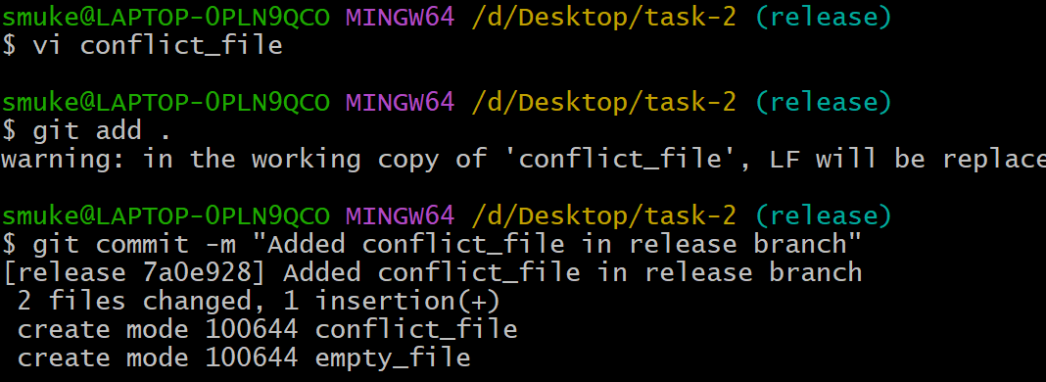

Step 2: switch to another branch and create a file with same name and commit it

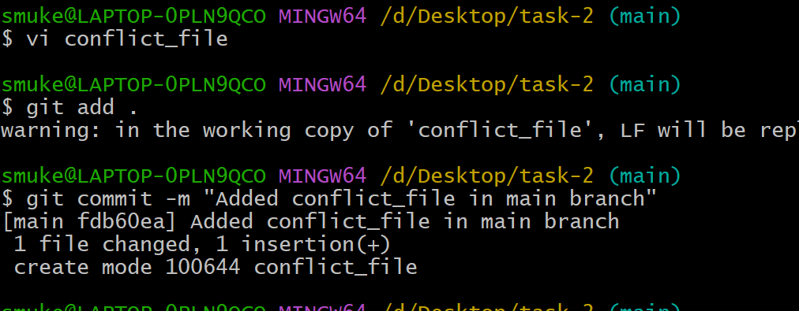

Step 3:Switch to previous branch modify the file and commit it.

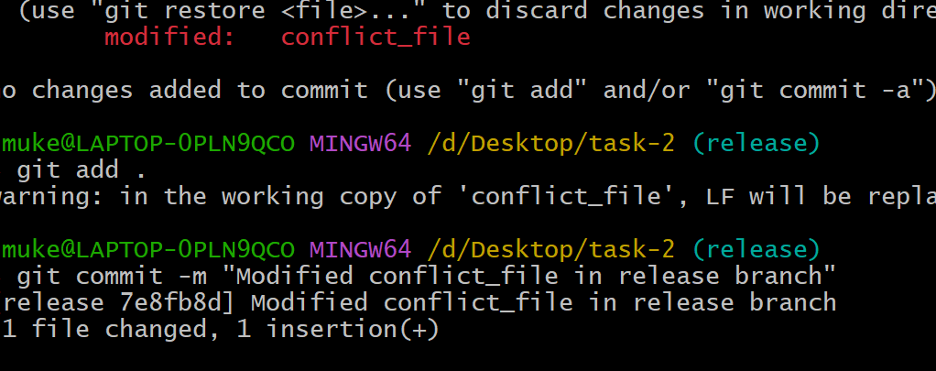

Step 4: Now comeback to other branch and give **git merge branchname c**onflict will occur

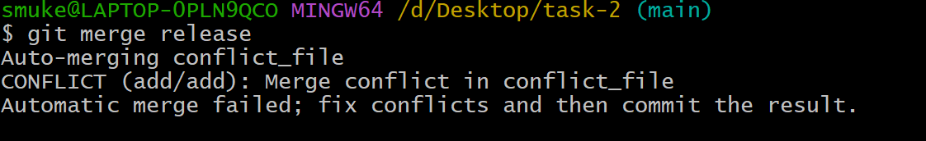

Step 5: Use **git status** to find which file has conflict issue

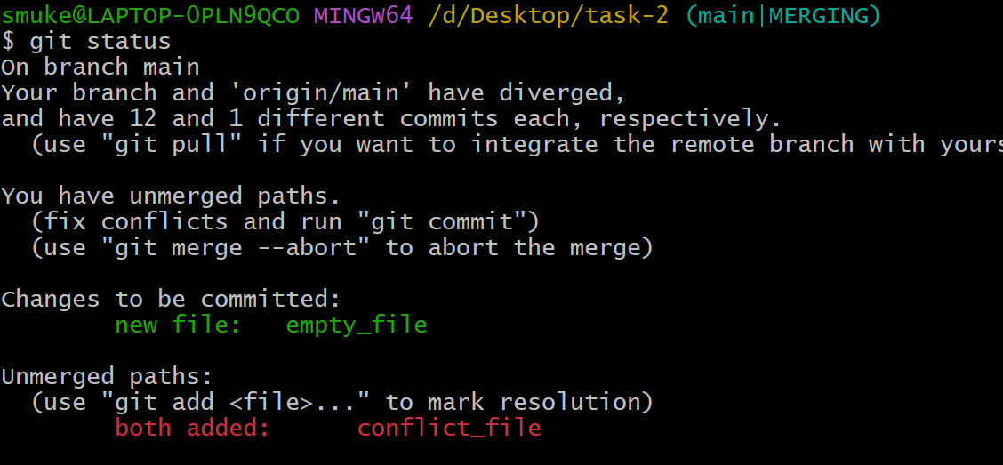

Step 6: Manually change the data of the file and commit again.

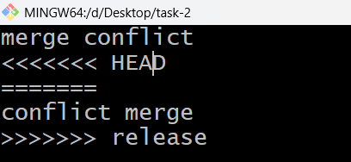

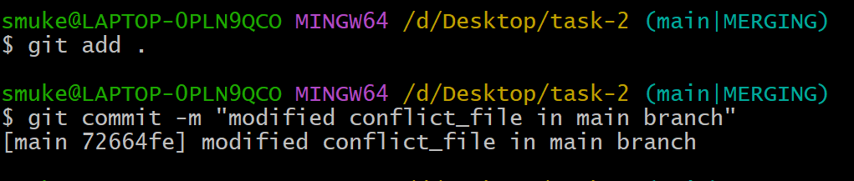

1. Recover deleted branch.

Step 1: switch to other branch and use **git branch -d branch_name** to delete a branch.

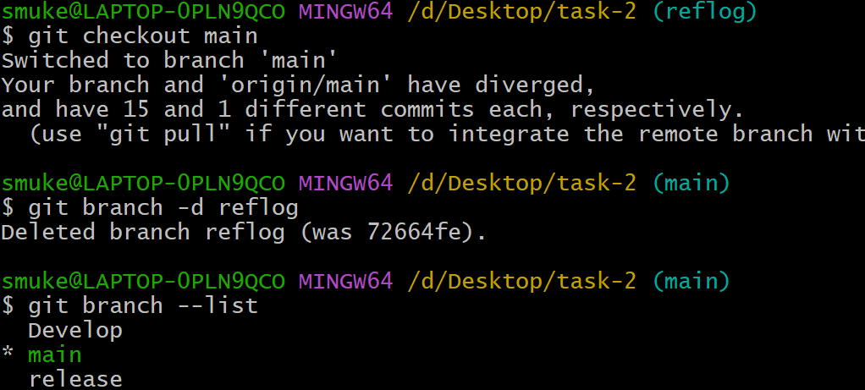

Step 2: Use **git reflog** to get commit it and copy latest commit id.

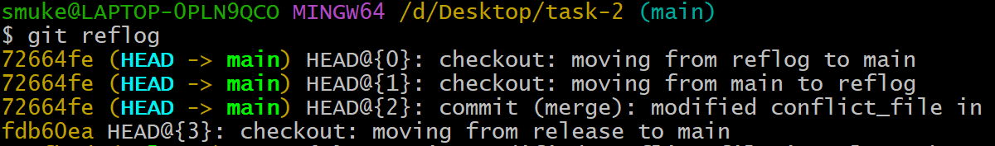

Step 3: Use **git checkout -b branch_name commit_id** to recover branch

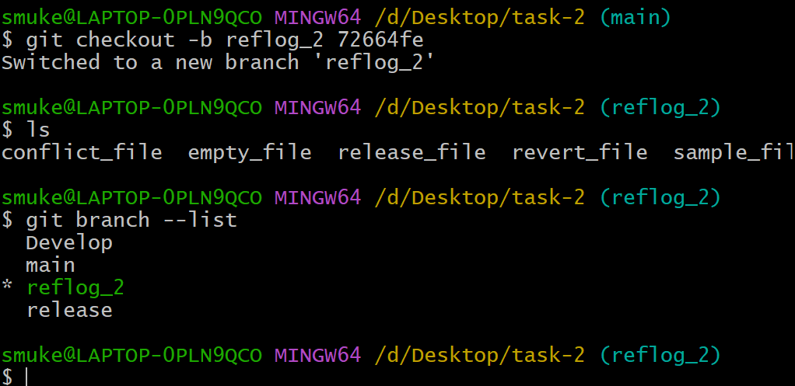

1. Undo wrong push

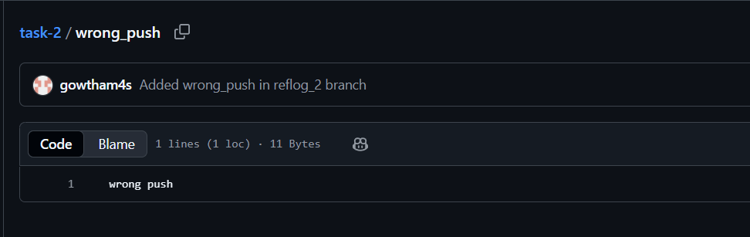

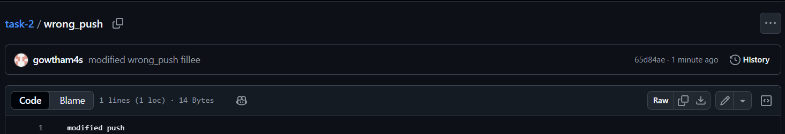

Step 1: Use **git log** to find commit id and copy commit id

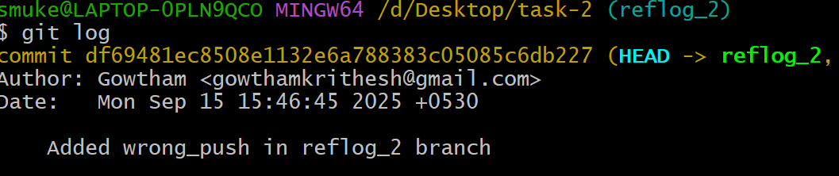

Step 2: use **git reset --hard commit_id**

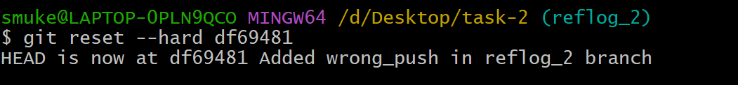

Step 3: Use **git push origin branch_name --force** to revert changes

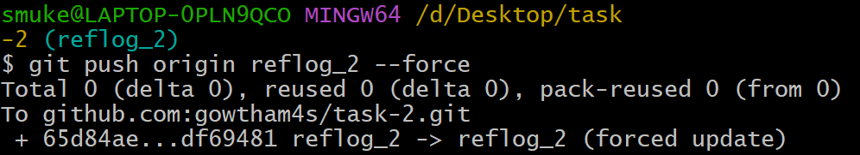

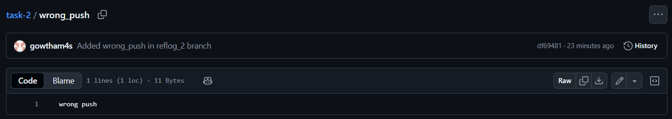

1. Amend a commit.

Step 1: Use **git commit –amend** to edit commit message



Step 2: Edit the message

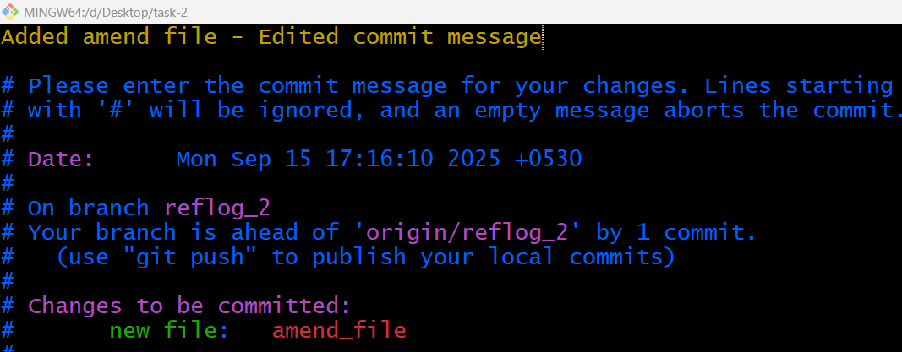

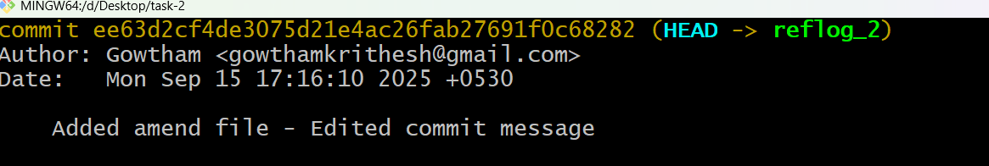

1. Cherry-Pick a commit.

Step 1:Create a file and commit it

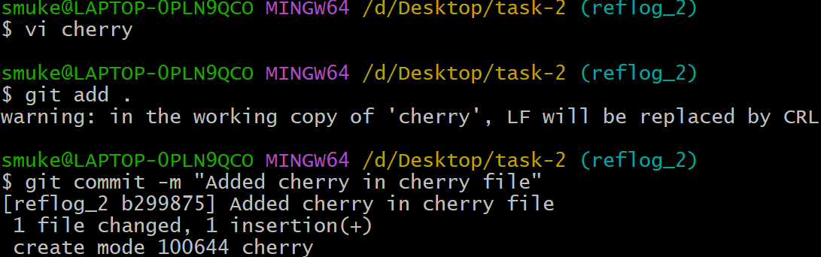

Step 2: Use **git log --oneline** to get commit id and switch to other branch

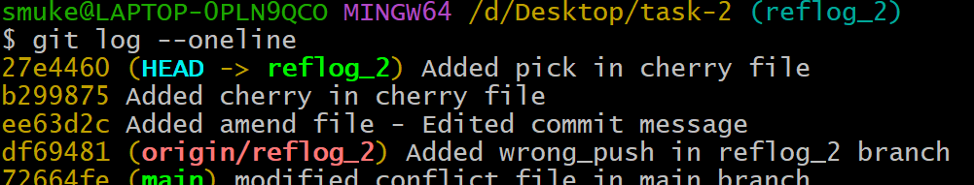

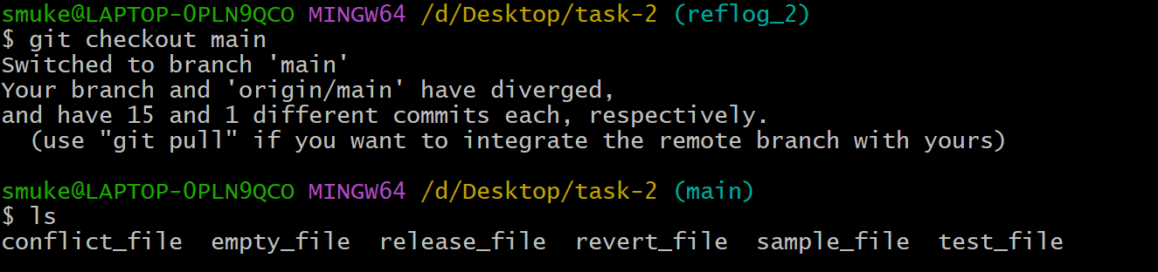

Step 3: Use **git cherry-pick commit_id** to merge specific commit

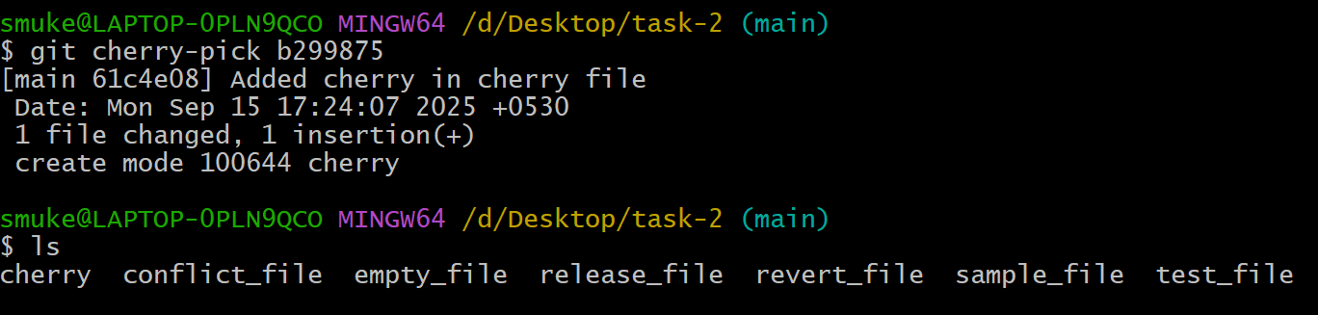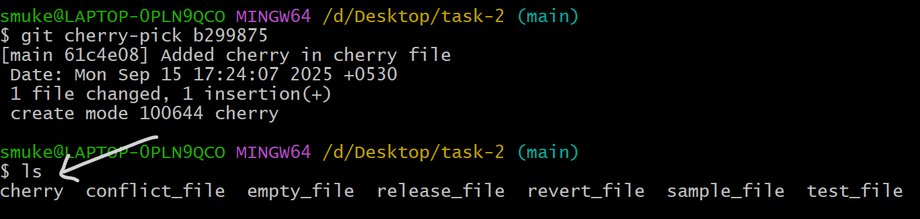

1. Interactive Rebase

Step 1: Use **git rebase -i HEAD~4** to squash last 4 commits



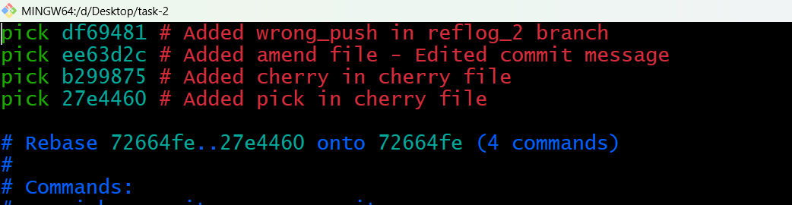

Step 2: Change the commits to be squashed from **pick** to **squash** and save it.

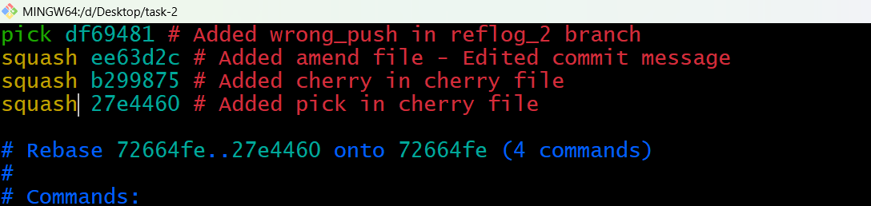

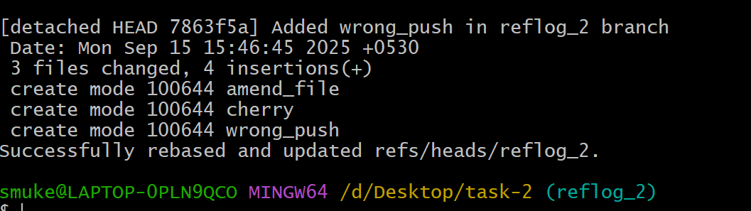

Step 3:Use **git log** to check the change

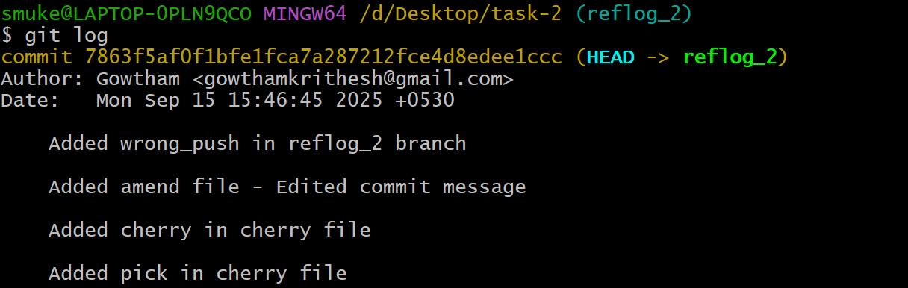

1. Tagging & Release

Step 1: Use **git tag -a tag_name -m “Tag message”** to create a tag



Step 2: Use **git push origin tag_name** to push it to github

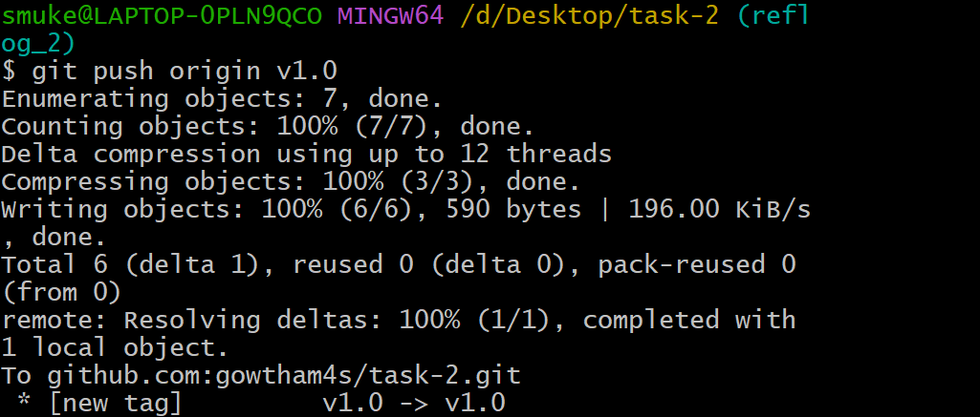

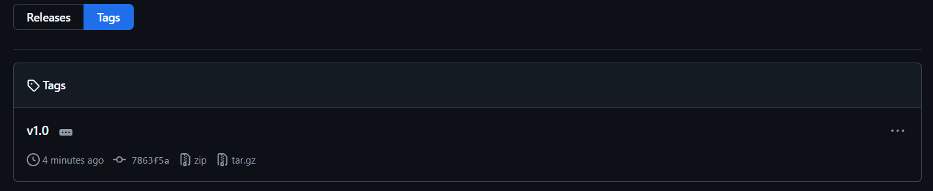

Step 3: Use **git tag -d v1.0** to delete the tag in Git.

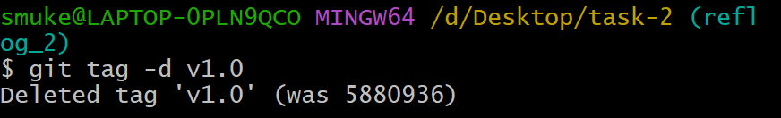

Step 4: Use **git push origin --delete tag_name** to delete tag in GitHub.

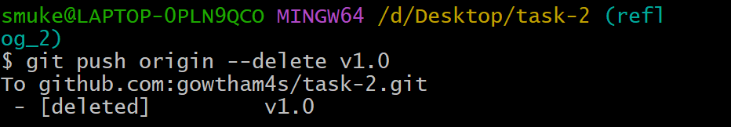



1. Clone with sparse checkout.

Step 1: Use **git clone --no-checkout repo_link** to clone and give **cd repo_name**

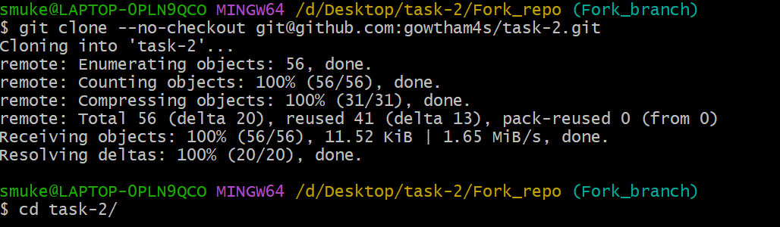

Step 2: Use **git sparse-checkout init --cone** to enable sparse checkout for current directory

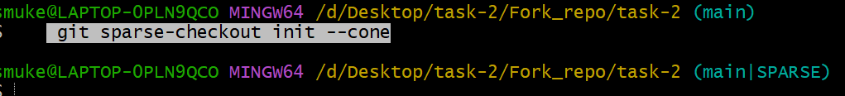

Step 3:Use **git sparse-checkout add directory_path** to sparse checkout configuration



Step 4: Use **echo “path/to/directory” >> .git/info/sparse-checkout**



Step 4: Use **git sparse-checkout set file_name &** **git checkout branch_name**

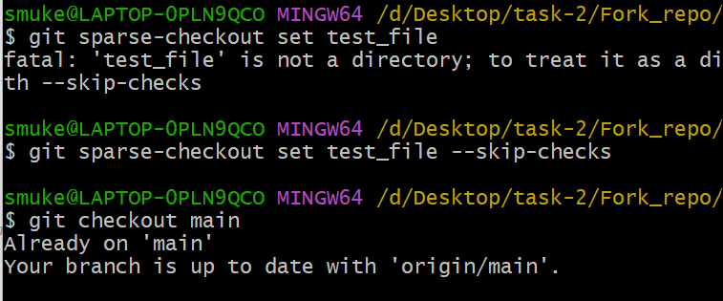

1. Reset vs Revert

**Reset**

**git reset --hard commit_id** will rewrites the project history. It moves the HEAD pointer and the current branch reference to the specified **commit.**

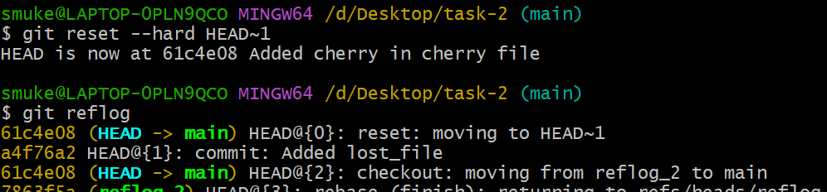

**Revert**

**git revert commit_id** creates a new commit that undoes the changes introduced by the specified **commit.** 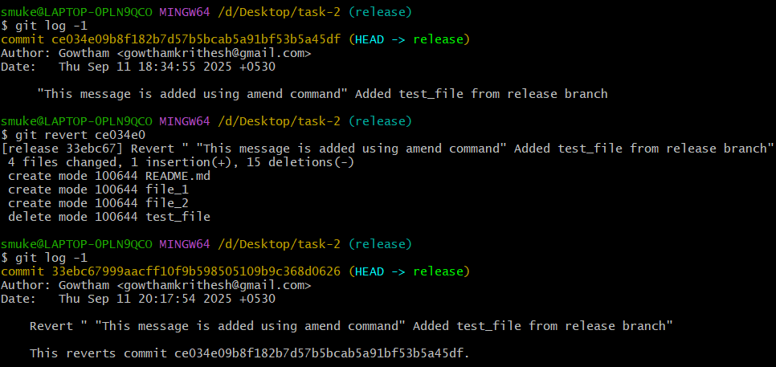

1. Detached HEAD challenge

Step 1: Use **git log –online** to get the commit id.

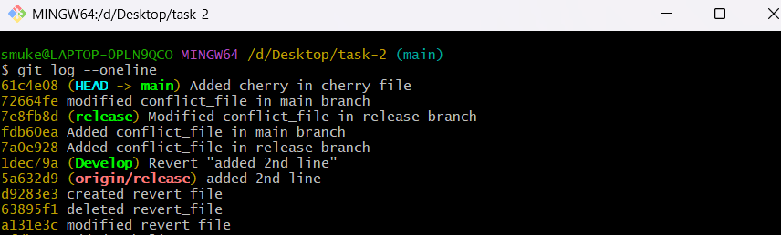

Step 2: Use **git checkout commit_id** to switch to that commit_id.

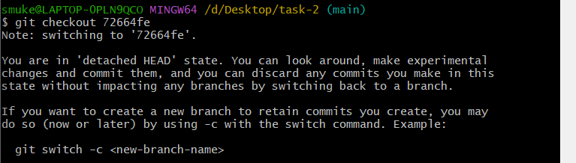

Step 3: Use **git checkout -b new_branch_name** to create new branch and retain commit.

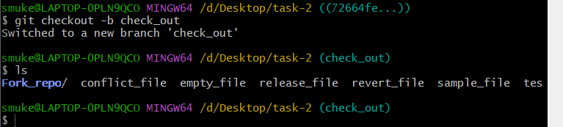

1. Git Hooks Challenge

Step 1: Use **cd .git/hooks/** and enter the scrip in **commit-msg** file

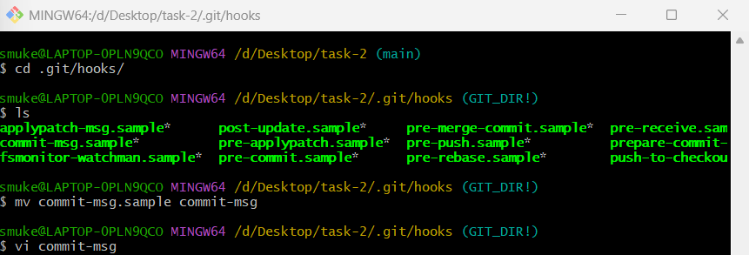

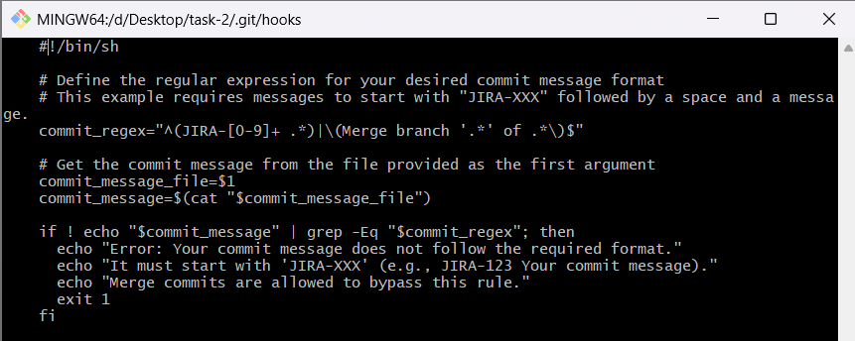

Step 2: Use **chmod +x commit-msg** to give executable permission to the file.



Now, whenever you attempt to commit, this commit-msg hook will automatically check if your commit message adheres to the specified "JIRA-XXX" format or not. If doesn’t commit will be rejected with error message.



1. Squash Merge vs Rebase Merge.

**Squash Merge**

A squash merge will consolidate all commits from other branch into a single new commit on the target branch.

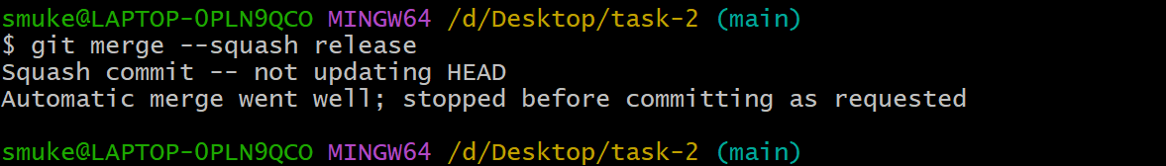

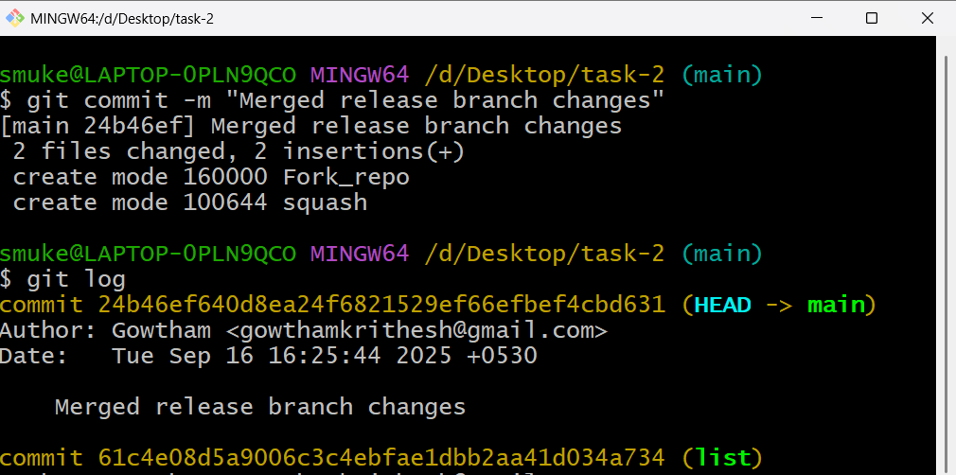

**Rebase Merge**

A rebase merge rewrites the commit history of the other branch by moving its base to the tip of the target branch.

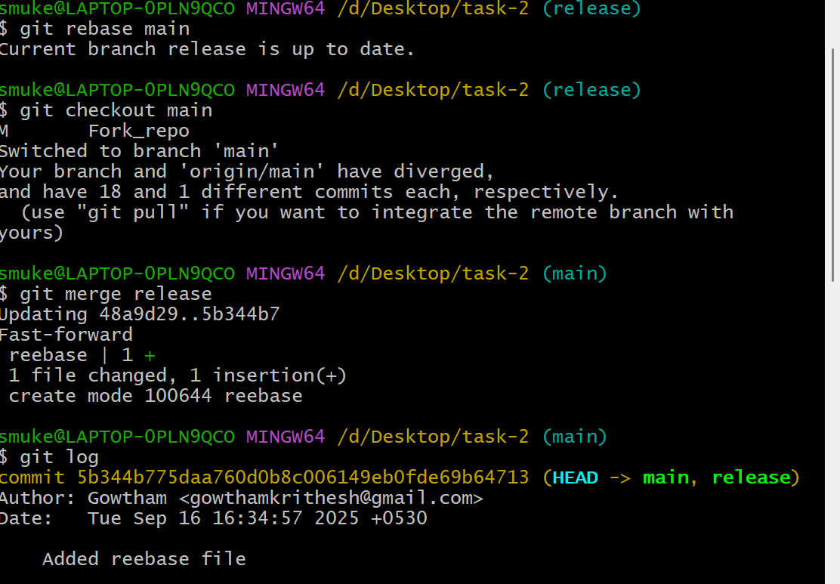

13. Fork & Pull request workflow

Step 1: open other repo click Fork 🡪create a new fork

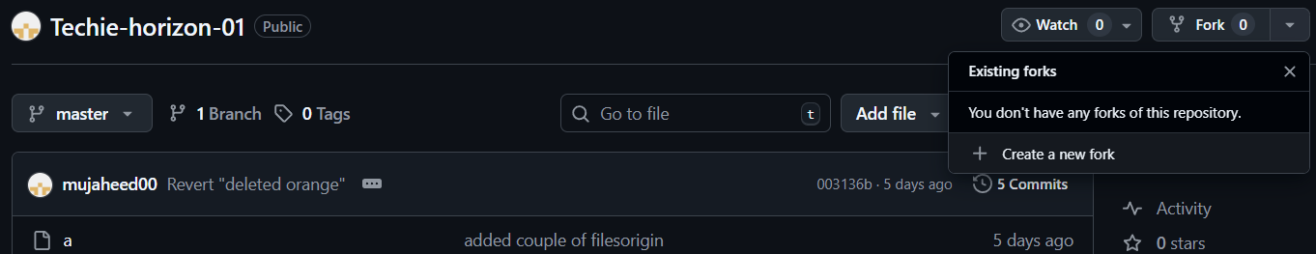

Step 2: Give repo name and click create fork

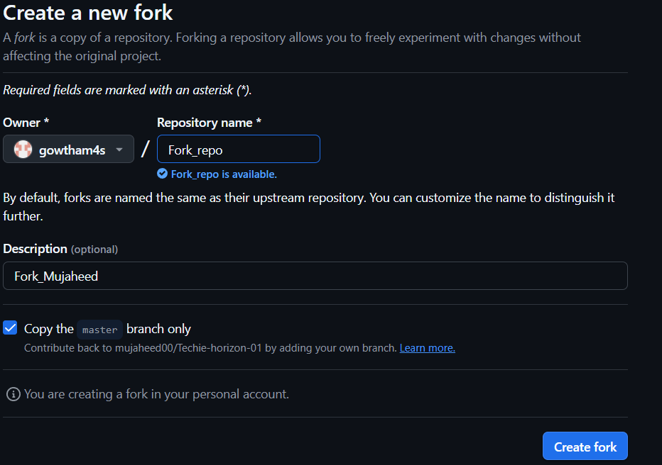

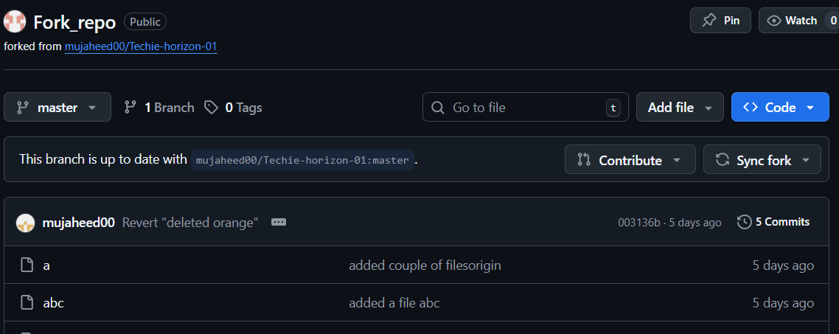

Step 3: Now in Git Enter **git clone fork_repo_url** and **cd Fork_repo_name**

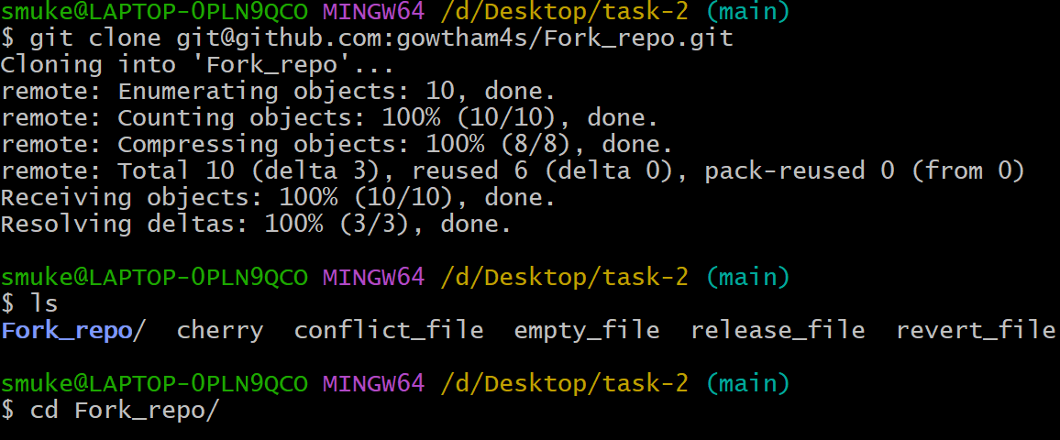

Step 4: Edit any file and push it.

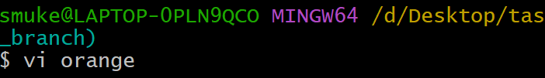

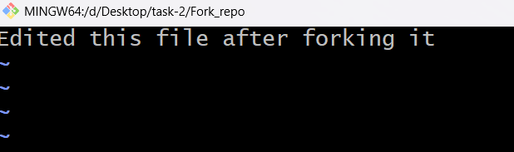

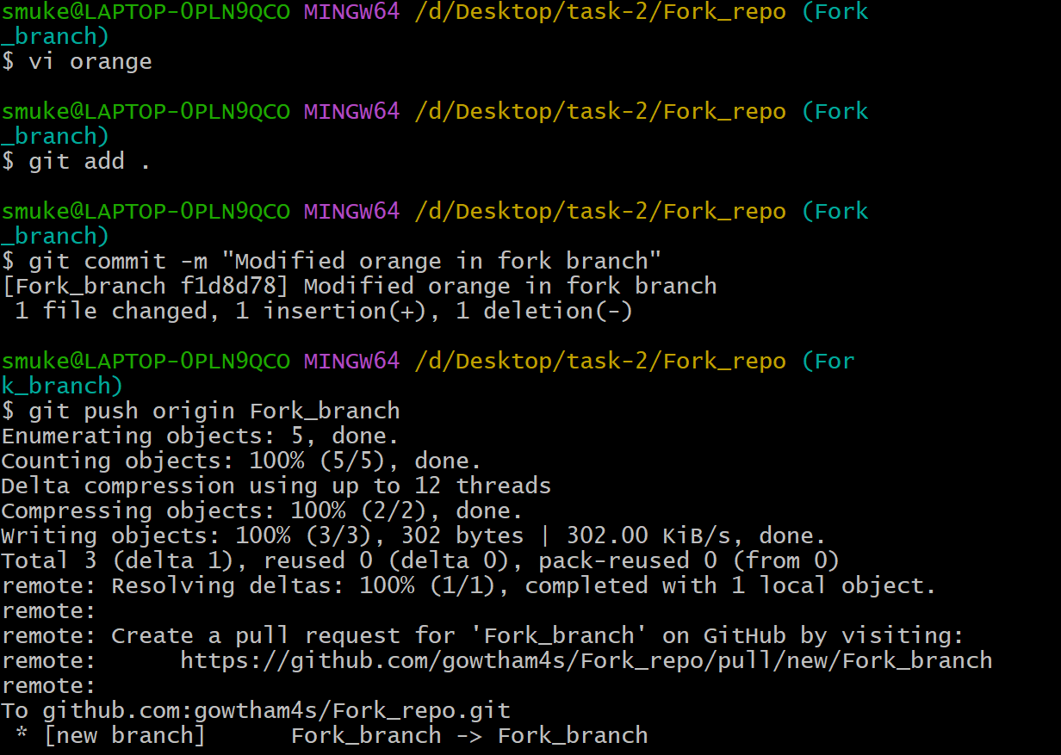

Step 5: Now go to original repo there you can see **compare & pull request**

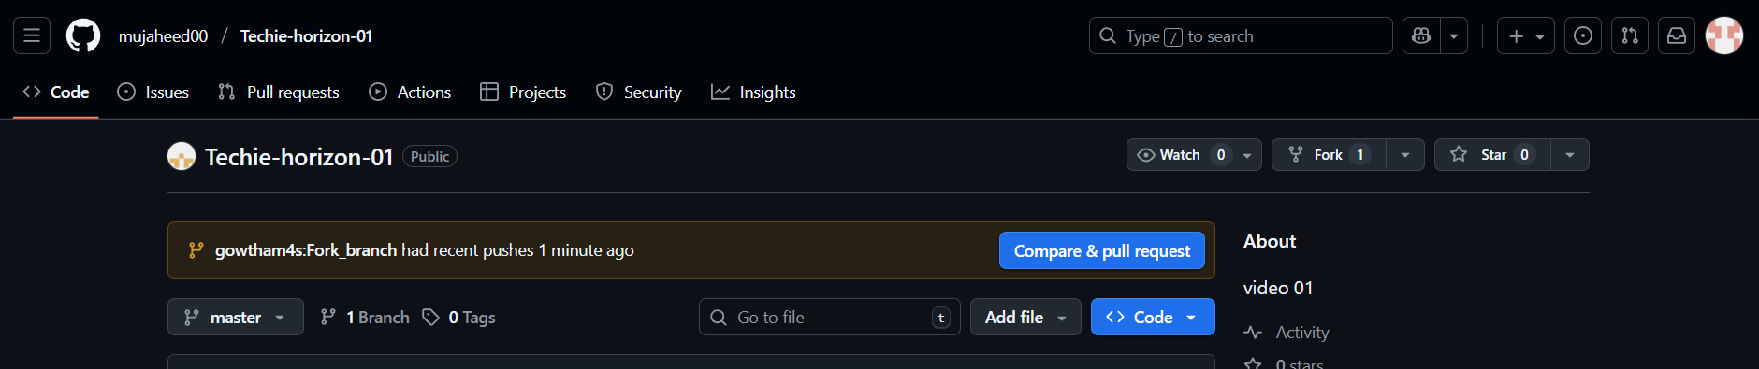

14. Recover lost commit.

Step 1: Create a file and commit it.

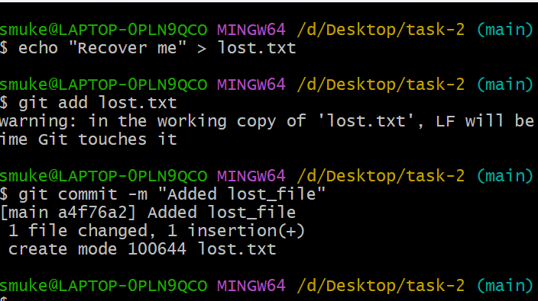

Step 2: Use **git reset --hard HEAD~1** to revert one commit back and **git reflog** to list commit.



Step 3: Use **git checkout -b recovery-branch commit_id** to create new branch at that commit

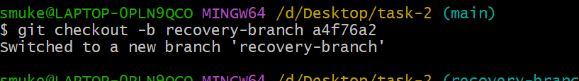

Step 4: Use **git reset --hard commit_id** to move head back to that commit

